Communication Protocols For The Old Screwing Cell

Robot Controller - PLC Communication (ModBus Over TCP/IP)
The PLC is the client and the Robot Controller is the server.
(The data is only saved with only translation and orientation) as well as the robot current (in mA)
The robot data from the robot is pulish with around 115Hz, we are sampling with around 400-500Hz.

PLC - PC Communications (Snap7)
A script is made in python to communicate using the python-snap7 module, this is a wrapper for the snap7 library. It is an Ethernet communication suite to interface with Siemens S7 PLCs.
Link to doc: https://python-snap7.readthedocs.io/en/latest/introduction.html

PLC - Screwdriver Controller (Digital Inputs and outputs (IO))
Here is Digital inputs and outputs used to start the screwing program on the controller and selecting what screwing program should run.
3 different programs have been implemented, normal, under tightened and over tightened screwing process.

Robot Controller - PC Communications(ModBus over TCP/IP)
On the PC side a python script using pyModbusTCP module. It is just sampling as fast as possible on the pc side, resulting in varying sampling frequency.

PC - Screwdriver Controller Communications(COM Port)
The PC and screwdriver controller communicate over a COM port using a USB cable, on the PC Weber’s WSK3 is running and set to save the screwdriver data from process as an kxml file on the pc on a selected directory.

PC - Microphone Communications()
Microphone used Azure Kinect ( on the pc it just shows up as a microphone)
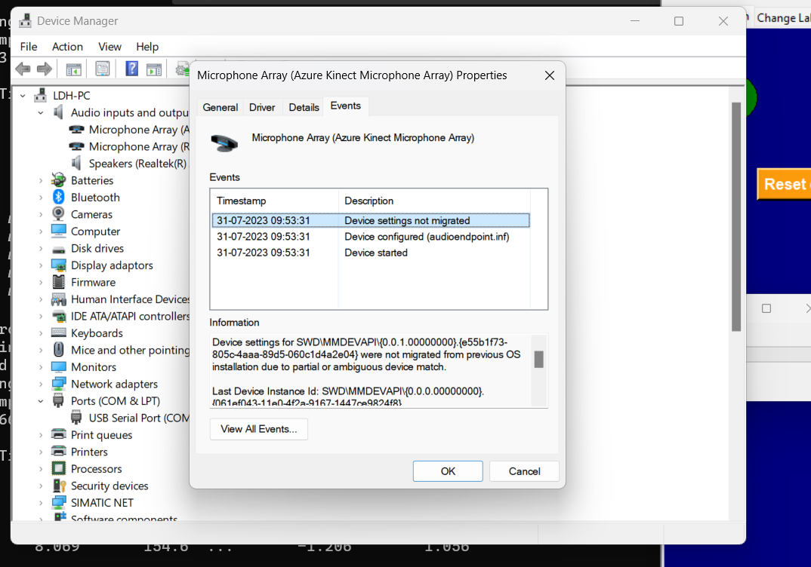
1 Channel is used
Sampling rate 44100

